- Country Overview
In this international venture Tranquilo are attempting to enter the French market and gain market shares in the industry for baby and child-specific products. One step in preparing for a venture like this is to look at the foreign market to see how various factors relating to doing business there may affect Tranquilo’s attempt at successfully entering the market. When assessing this economic, political, cultural, legal and technological factors will be looked at.

According to CIA (2016) France is a leading European economy with a strong economy that is diversified across all sectors. In 2015 France had a population of around 66,8 million and their GDP accounted for $2.422 trillion (World Bank, 2016). The GNI per capita was $40,580 which ranks as the 22nd highest globally. The World Bank Doing Business (2016) states that France ranks 78 globally regarding getting credit and concerning tax payment the rank as 61 with for example a corporate income tax level of 33.33%. Further, PWC (2012) states that France has a well set up system for foreign investments with no administrative restrictions. IP protection laws are considerd strong and the legal framework surrounding that is strong and enforced by the government. France ranks as 29 overall on the World Banks Ease of doing business list (World Bank, 2016) and PWC (2012) states that it is a strong, modern economy with high purchasing power among the citizens. Seeing that it is the worlds fifth strongest economy also makes France a suitable and interesting choice of market in this regard.
According to the World Bank (2016) France ranks at 25 regarding starting a business. In that, factors such as time to set up a business and costs connected to that are considered.
It is important to consider cultural factors when looking at entering a foreign market as these factors can affect how successful the venture might be. Hofstede Centre (2016) provides information on cultural dimension that can be relevant to look at before a business venture. The illustration below show a comparison between the United States and France.
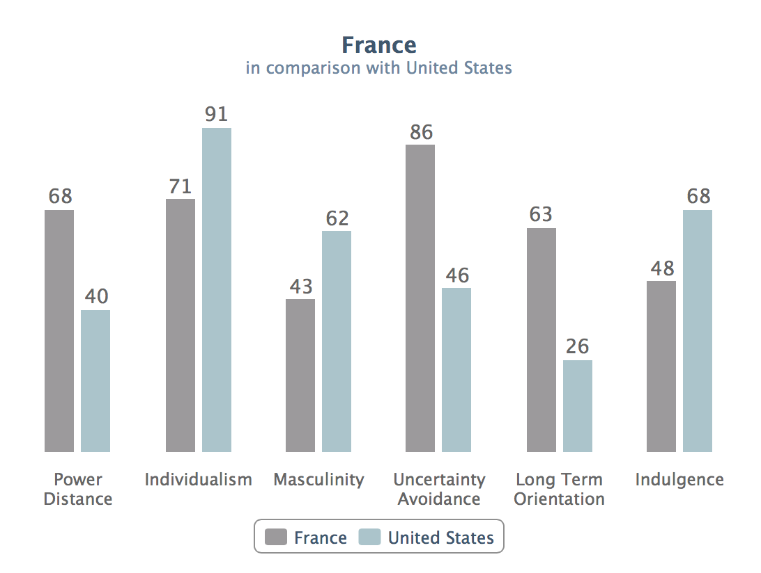
In this we can see that France ranks substantially higher in uncertainty avoidance. This means that the risk taking is lower in France and that business to a greater extent than in the U.S. wishes to plan every aspect in advance in order to avoid uncertainty and surprises. They also rank higher than the U.S. in Power Distance. A higher score in this means that people in France are more used to a clear difference in authority between people in different levels of an organization.

All of these factors needs to be considered before making Tranquilo can make an international venture. The legal framework is France is considered strong and fair which is favorable for a foreign company looking to enter the market. Further, the economy in France is strong and the purchasing power among the people is high, so if successful Tranquilo has the chance of attracting several customers that are willing and able to purchase their product. As a highly developed country all technological necessities are present on the French market, with everything from a strong infrastructure to internet subscriptions, again acting as an opportunity for Tranquilo.

Factor endowments
The factor endowments are concerned with elements that make it possible for a country’s economy to create and create a competitive business landscape. These elements include a skilled labor force, technical innovation, capital and infrastructure. France has a strong and reliable infrastructure which is positive for foreign companies looking to enter the market. One aspect that is relevant for Tranquilo is the skilled labor force. This is important as they most likely will need employees in France capable of conducting all of the needed business activities. France has a string skilled labor force but have recently shown a decrease in this sector (McKinsey, 2012). However, the declining skilled labor force should not act as a major problem for the firm as other related and supporting industries are already present on the market. The business landscape in France, especially in the major cities, offer Tranquilo sufficient possibilities to obtain the labor force they need. Tranquilo is manufacturing their product in China and the idea is, in order to remain a low-cost production, to keep the manufacturing there. This means that the competitive advantage they have comes in terms of price due to the Chinese market conditions and the advanced factors of condition in France will not play a part in this venture.
Supporting and Related Industries
TranquiloLLC is classified in baby product industry. Tranquilo mat is very simple and makes from popular materials include cotton, water system, and a simple battery motor. Therefore, our supporting and related industry is textile manufacturing industry and electronics equipment industry, which is very competitive industry. Electronics equipment and textiles industries are two of the France leading industries in 2016 with 2664 children textile manufacturing firms and 259 battery suppliers in France (Battery, 2016), (Clothes, 2016), (France, 2016). When supporting industries are competitive, the company can have advantages from cost effective as well as achieve more innovative inputs. Moreover, related industries are very importance. The France baby product industry benefits from the growth and development of children textile manufacturing and electronics equipment industries, which have strengthened the competitiveness of the France baby product industry (Diamond, 2016).
Home demand

Population: By having 2.01 children each woman, France is one of the top fertile countries in Europe, placed just behind Ireland. France therefore stands out from the rest of the EU, where the average fertility rate is approximately 1.6 children per woman.And nearly 60% of young French persons want to have a family and children. This is the highest rate in Europe according to a study carried out in 2011 by the Foundation for Political Innovation. It indicates very strong potential market demand in France, even in the future. (With 2.01 child per woman)
Country | 2000 | 2001 | 2002 | 2003 | 2004 | 2005 | 2006 | 2007 | 2008 | 2009 | 2010 | 2011 | 2012 | 2013 | 2014
France | 12.27 | 12.1 | 11.94 | 12.54 | 12.34 | 12.15 | 11.99 | 12.91 | 12.73 | 12.57 | 12.43 | 12.29 | 12.72 | 12.6 | 12.49
(Average yearly number of births during a year per 1,000 persons in the population)
Source: France birth rate

The price of the domestic competitors’ is higher than Tranquilo. Most of Bebe confort products are more than $100~$ 600, like stroller , bayby keyo lounger and the products of Baby moov are also 40% more expensive than Tranqulio. The domestic consumers are highly like to move to Tranquilo due to competitive price.
GNP (income) :Over the 10 years before the economic calamity, France’s GDP raised 2.0% on average per year. However, recovery has been sluggish and the economy has stalled since 2009, with atypical economic growing rate of 1.1% per year from 2009 to 2013. Recently, France’s economy has stuck, failing to grow in 2012. Private consumption has conventionally been the main force of economic growth in France but, in 2012, private consumption decreased for the first time in over two decades andconsumer confidence levels had deteriorated and led to slow economic growth rates.
 | 2011 | 2012 | 2013 | 2014 | 2015
Economic Growth (GDP, annual variation in %) | 2.1 | 0.0 | 0.8 | 0.2 | 1.2

For this reason, the consumption pattern of young parents would be very careful and sensitive to the price of the products. Tranquillo will be very competitive compared to rivalries in terms of price. (GDP in France)
Firm strategy , structureand Rivalries
France positions 27th in the world for opening a business, based on the World Bank and International Finance Corporation (IFC). Typically French companies have a very clear, upright line of order with upper management.In case of dealing with long-term strategies and important business decisions, people have to do that with the CEO. So it’s important to thoroughly prepare how to appeal your ideas to them. To start business in France, it requires five steps and seven days to set up, withregistration with the Centre de Formalités des Entreprises (CFE) and having company books stamped and marked by the office worker of the commercial court. Companies must attain an urbanism credential, a building permit and a obedience certificate, as well as getting the mandatoryendorsement for opening a location and connecting it to water and electricity works. They need to get registering property and credit, too. (Global reach. Local Knowledge)
In French companies, there are some legal structures the companies need to adopt.Financial responsibility is restricted to the sum of owners’ contributions to the company. The most prevalent company systems are the société à responsabilité limitée (SARL), the société par actions simplifiée (SAS) and the société anonyme (SA). SARL and SAS can be designed with a single shareholder, while seven stockholders are mandatory for an SA. The SA is the most complicated type of French company and is able to inaugurate a public contribution. The SAS is the newest form of French company and overseas companies wishing to keep 100% control of one of their affiliates. Selecting a legal structure will influence the company’s legal standing, taxes, properties and employ relations. (Doing business in France , 2015)
Bebe confort has become mother’s favored brand for the third successive years in France due to its innovative products. It is one of the oldest baby products brands and highly appreciated for its good quality and various products.Alos, it is the French front-runner of baby products with strollers, car safety, bottle feeding making parents life easier day after day. (Bebe confort celebrate its 80th birthday).

References:

CIA World Factbook. (2016). France.Retrieved from:
https://www.cia.gov/library/publications/the-world-factbook/geos/fr.html

The World Bank. (2016). Doing Business-France. Retrieved from:
http://www.doingbusiness.org/data/exploreeconomies/france/

The World Bank. (2016). France.Retrieved from:
http://data.worldbank.org/country/france

PWC. (2012). Doing business in France. Retrieved from:
https://www.pwc.de/de/internationale-maerkte/assets/doing-business-in-france.pdf

Business Culture. (2014). Business Culture in France.Retrieved from:
http://businessculture.org/western-europe/business-culture-in-france/

